# Applecross Senior High School

### Semester One Examination, 2020

### Question/Answer booklet

# MATHEMATICS

**SOLUTIONS**

**METHODS**

**UNIT 1**

## Section One:

## Calculator-free

|  |  |  |  |  |  |  |  |  |  |  |
| --- | --- | --- | --- | --- | --- | --- | --- | --- | --- | --- |
| WA student number: In figures |  |  |  |  |  |  |  |  |  |  |

In words

Your name

|  |  |
| --- | --- |
| Number of additional answer booklets used (if applicable): |  |

## Time allowed for this section

Reading time before commencing work: five minutes

Working time: fifty minutes

## Materials required/recommended for this section

***To be provided by the supervisor***

This Question/Answer booklet

Formula sheet

***To be provided by the candidate***

Standard items: pens (blue/black preferred), pencils (including coloured), sharpener,  
correction fluid/tape, eraser, ruler, highlighters

Special items: nil

## Important note to candidates

No other items may be taken into the examination room. It is **your** responsibility to ensure that you do not have any unauthorised material. If you have any unauthorised material with you, hand it to the supervisor **before** reading any further.

## Structure of this paper

|  |  |  |  |  |  |
| --- | --- | --- | --- | --- | --- |
| Section | Number of questions available | Number of questions to be answered | Working time (minutes) | Marks available | Percentage of examination |
| Section One: Calculator-free | 8 | 8 | 50 | 52 | 35 |
| Section Two: Calculator-assumed | 13 | 13 | 100 | 98 | 65 |
|  | | |  | **Total** | 100 |

## Instructions to candidates

1. The rules for the conduct of examinations are detailed in the school handbook. Sitting this examination implies that you agree to abide by these rules.

2. Write your answers in this Question/Answer booklet preferably using a blue/black pen.  
Do not use erasable or gel pens.

3. You must be careful to confine your answers to the specific question asked and to follow any instructions that are specific to a particular question.

4. Show all your working clearly. Your working should be in sufficient detail to allow your answers to be checked readily and for marks to be awarded for reasoning. Incorrect answers given without supporting reasoning cannot be allocated any marks. For any question or part question worth more than two marks, valid working or justification is required to receive full marks. If you repeat any question, ensure that you cancel the answer you do not wish to have marked.

5. It is recommended that you do not use pencil, except in diagrams.

6. Supplementary pages for planning/continuing your answers to questions are provided at the end of this Question/Answer booklet. If you use these pages to continue an answer, indicate at the original answer where the answer is continued, i.e. give the page number.

7. The Formula sheet is not to be handed in with your Question/Answer booklet.

Section One: Calculator-free 35% (52 Marks)

This section has**eight** questions. Answer **all** questions. Write your answers in the spaces provided.

Working time: 50 minutes.

Question 1 (5 marks)

The point $M(-2, 5)$ is the midpoint of point $A(-6, 3)$ and point $B$.

(a) Determine the coordinates of point $B$. (2 marks)

|  |
| --- |
| **Solution** |
| $$\frac{-6+x}{2}=-2⇒x=2$$ $$\frac{3+y}{2}=5⇒y=7$$ $$B(2, 7)$$ |
| **Specific behaviours** |
| ✓ correct $x$-coordinate  ✓ correct $y$-coordinate |

(b) Determine the equation of the straight line that passes through point $C(4, -1)$ and is perpendicular to the line through points $A$ and $M$. (3 marks)

|  |
| --- |
| **Solution** |
| $$m_{AM}=\frac{5-3}{-2-(-6)}=\frac{1}{2}$$ $$m_{⊥}=-1÷\frac{1}{2}=-2$$ $$y-\left(-1\right)=-2\left(x-4\right) \\ y=-2x+7$$ |
| **Specific behaviours** |
| ✓ gradient of $AM$ ✓ perpendicular gradient  ✓ correct equation |

**Question 2 (4 marks)**

Expand and simplify the following.

(a) ${\left(x-9\right)}^{2}$. (1 mark)

|  |
| --- |
| **Solution** |
| $${\left(x-9\right)}^{2}=x^{2}-18x+81$$ |
| **Specific behaviours** |
| ✓ correct expansion |

(b) $(2x+1)(x-3)(x+7)$. (3 marks)

|  |
| --- |
| **Solution** |
| $$\left(2x+1\right)\left(x-3\right)\left(x+7\right)=\left(2x+1\right)\left(x^{2}+4x-21\right) \\ =2x^{3}+8x^{2}-42x+x^{2}+4x-21 \\ =2x^{3}+9x^{2}-38x-21$$ |
| **Specific behaviours** |
| ✓ correct binomial expansion  ✓ correct full expansion  ✓ simplifies correctly |

Question 3 (5 marks)

Functions $f$ and $g$ are defined by $f\left(x\right)=4x^{2}-4x+5$ and $g\left(x\right)=2x^{2}-8x+6$.

(a) Determine the discriminant of $f$ and the discriminant of $g$. (2 marks)

|  |
| --- |
| **Solution** |
| $$Δ_{f}={\left(-4\right)}^{2}-4\left(4\right)\left(5\right)=-64$$ $$Δ_{g}={\left(-8\right)}^{2}-4\left(2\right)\left(6\right)=16$$ |
| **Specific behaviours** |
| ✓ discriminant of  ✓ discriminant of $g$ |

(b) State, with justification, which function has no zeros and determine all zeros of the other function. (3 marks)

|  |
| --- |
| **Solution** |
| $f$ has no zeroes as $Δ_{f}<0$. $g\left(x\right)=0$ when $$x=\frac{-\left(-8\right)±\sqrt{16}}{2\left(2\right)} \\ x=2±1$$ $g$ has zeros when $x=1, x=3$. |
| **Specific behaviours** |
| ✓ states $f$ has no zeroes  ✓ indicates appropriate method to find zeros  ✓ both zeros of $g$ |

Question 4 (7 marks)

(a) Sketch the graph of $y^{2}=x$ on the axes below. (2 marks)

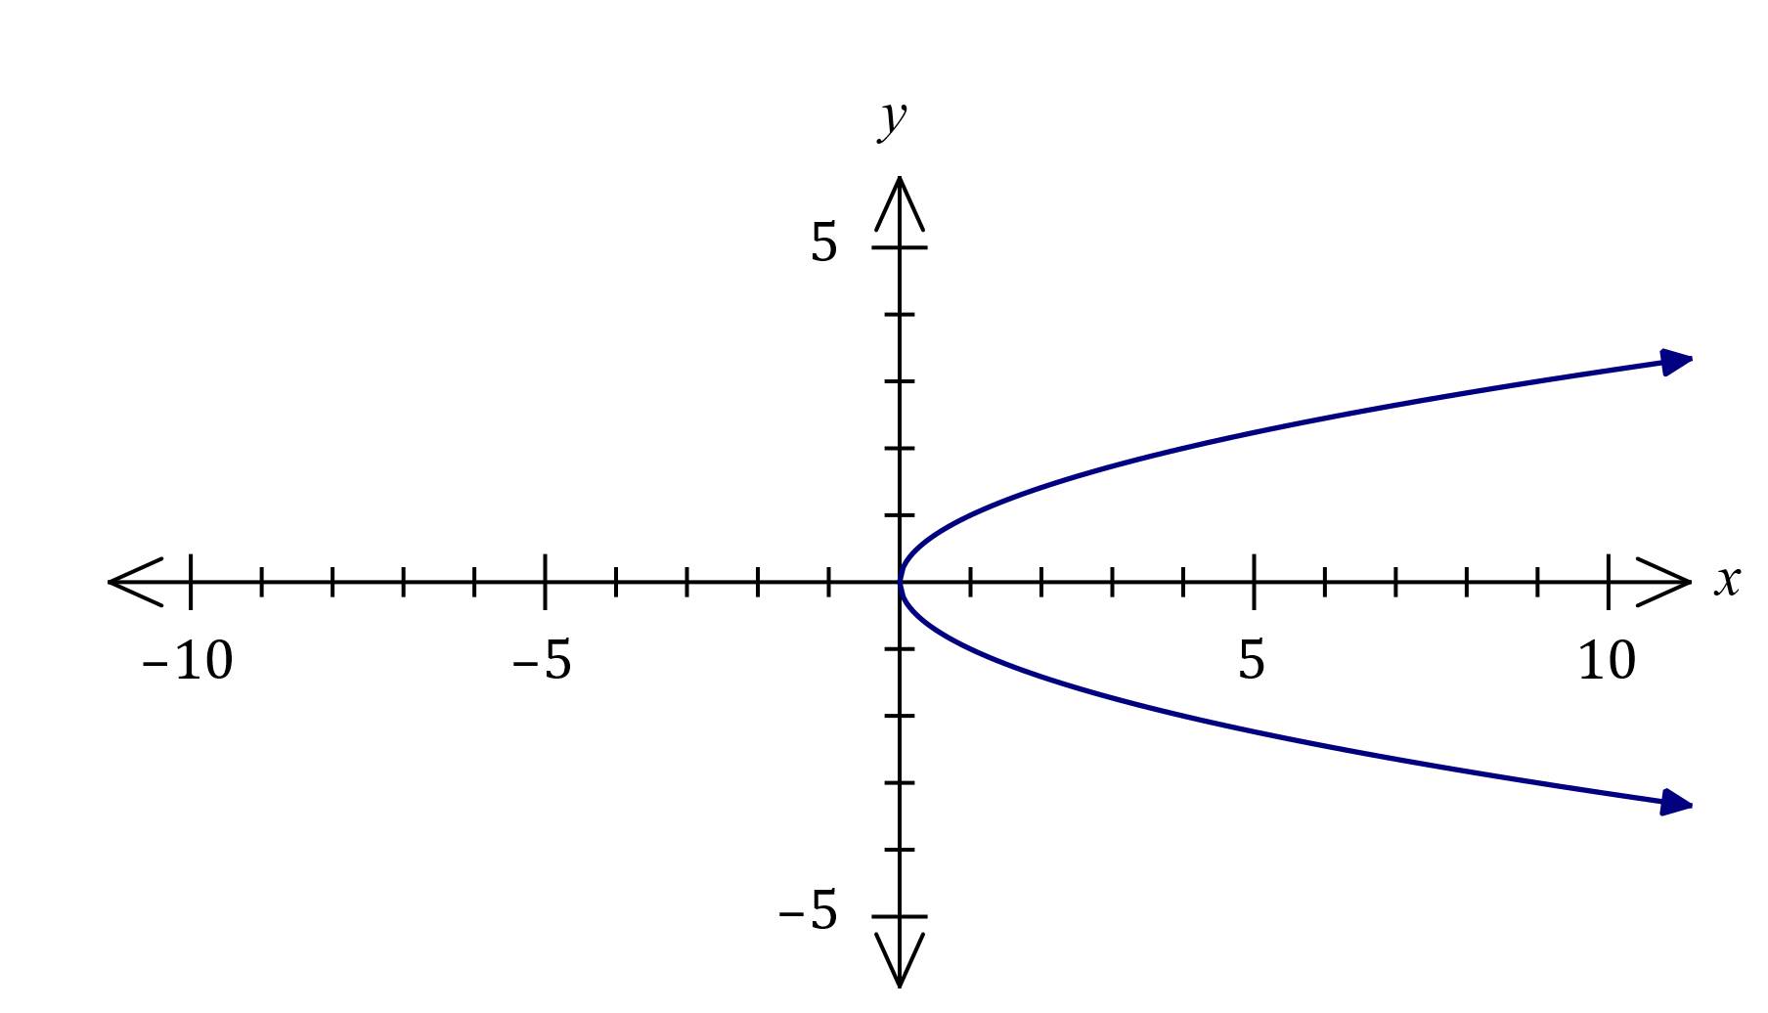

|  |
| --- |
| **Solution** |
| See graph |
| **Specific behaviours** |
| ✓ location of vertex  ✓ symmetric parabola |

(b) Sketch the graph of ${\left(x+1\right)}^{2}+{\left(y-1\right)}^{2}=4$ on the axes below. (3 marks)

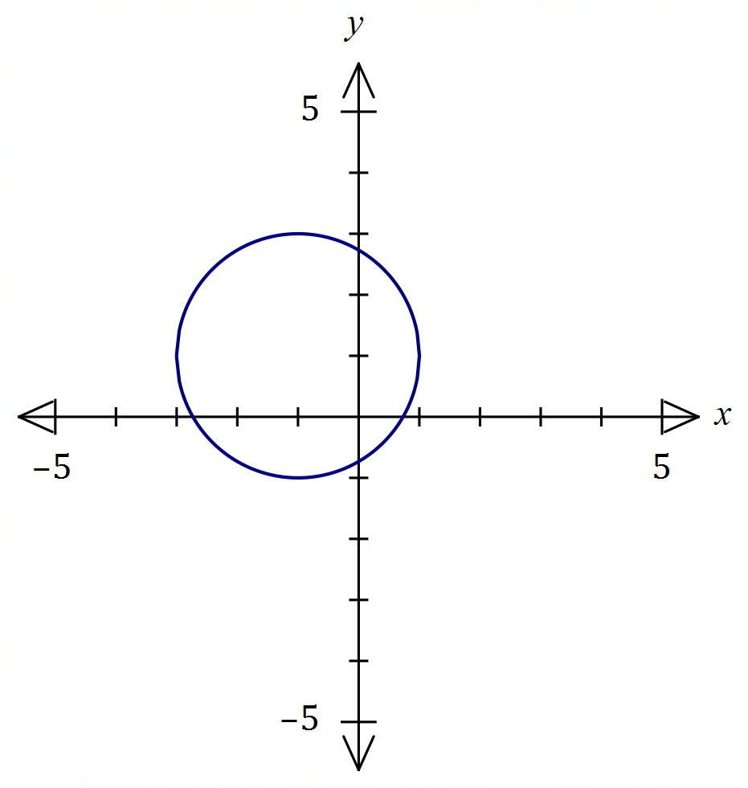

|  |
| --- |
| **Solution** |
| See graph |
| **Specific behaviours** |
| ✓ location of centre  ✓ correct radius  ✓ smooth circle |

(c) Explain whether $y$ is a function of $x$ in the relationship graphed in (a). (2 marks)

|  |
| --- |
| **Solution** |
| $y$ is NOT a function of $x.$ This is because the graph of the relationship fails the vertical line test. |
| **Specific behaviours** |
| ✓ states not a function  ✓ explanation (VLT, one-to-many, etc) |

Question 5 (8 marks)

(a) A periodic function is defined by $f\left(x\right)=2-2\sin{(3x)}$.

(i) State the amplitude of the function. (1 mark)

|  |
| --- |
| **Solution** |
| Amplitude is $2$. |
| **Specific behaviours** |
| ✓ correct amplitude |

(ii) State the period of the function in degrees. (1 mark)

|  |
| --- |
| **Solution** |
| Period is $360÷3=120°$. |
| **Specific behaviours** |
| ✓ correct period |

(iii) Sketch the graph of $y=f(x)$ on the axes below. (3 marks)

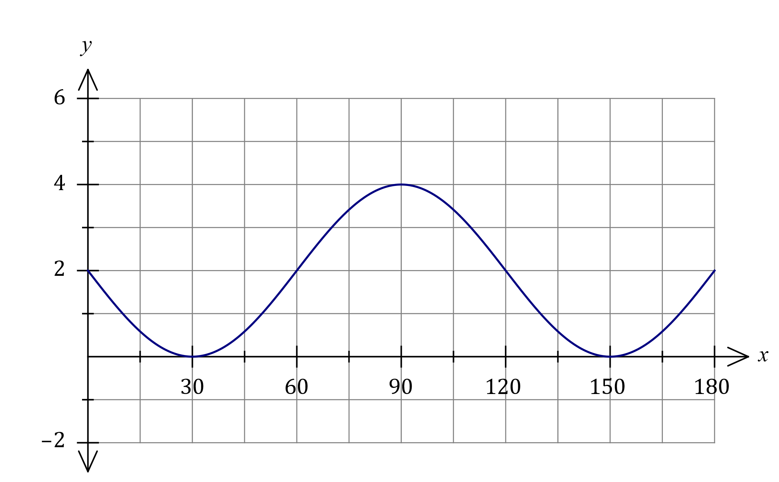

|  |
| --- |
| **Solution** |
| See graph |
| **Specific behaviours** |
| ✓ and $(180, 2)$ ✓ locates turning pts  ✓ smooth curve |

(b) Solve the equation $2\cos{(x-15°)}=\sqrt{3}$ where $0≤x≤360°$. (3 marks)

|  |
| --- |
| **Solution** |
| $$\cos\left(x-15°\right)=\frac{\sqrt{3}}{2} \\ x-15°=30°, 330° \\ x=45°, 345°$$ |
| **Specific behaviours** |
| ✓ determines an angle for $\frac{\sqrt{3}}{2}$ ✓ determines one solution  ✓ both correct solutions |

Question 6 (7 marks)

(a) The variable $V$ is inversely proportional to the variable $t$, so that when $t=3.6$, $V=10$.

(i) Explain how $V$ will change as $t$ increases. (1 mark)

|  |
| --- |
| **Solution** |
| As $t$ increases $V$ will decrease. |
| **Specific behaviours** |
| ✓ correct explanation |

(ii) Determine $t$ when $V=3$. (2 marks)

|  |
| --- |
| **Solution** |
| $$V×t=k⇒k=3.6×10=36$$ $$3t=36⇒t=12$$ |
| **Specific behaviours** |
| ✓ indicates appropriate method  ✓ correct value |

(b) Part of the graph of $y=\begin{matrix}a \\ \overline{x+2}\end{matrix}$ is drawn below.

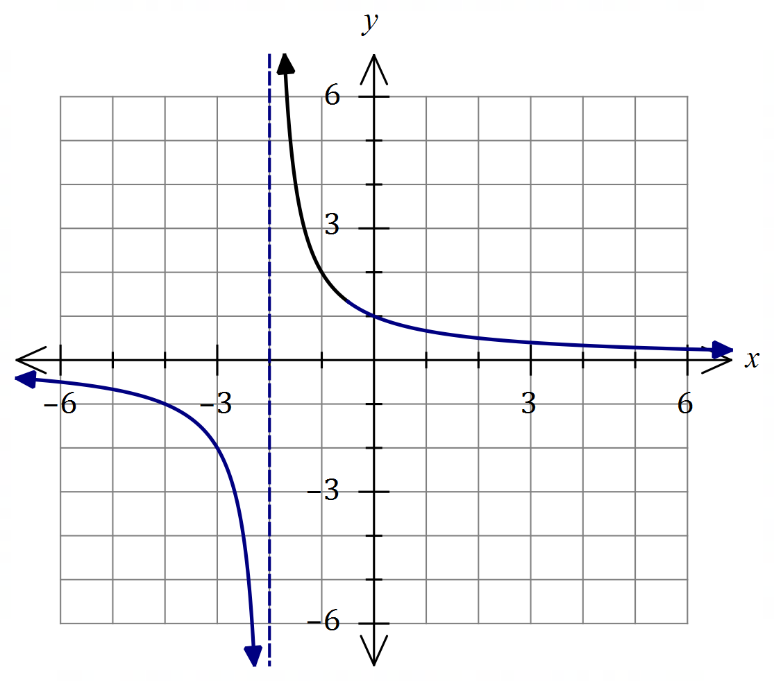

|  |
| --- |
| **Solution (b)(ii)** |
| See graph |
| **Specific behaviours** |
| ✓ asymptotes  ✓ thru' $\left(0, 1\right), \left(-4, -1\right)$ ✓ two smooth curves |

(i) Determine the value of $a$. (1 mark)

|  |
| --- |
| **Solution** |
| $$\left(-1, 2\right)⇒2=\frac{a}{-1+2}⇒a=2$$ |
| **Specific behaviours** |
| ✓ correct value |

(ii) Draw the remainder of the graph. (3 marks)

Question 7 (8 marks)

Solve the following equations for $x$.

(a) $x^{2}+20x-21=0$. (2 marks)

|  |
| --- |
| **Solution** |
| $$x^{2}+20x-21=\left(x-1\right)\left(x+21\right)$$ Hence $x=1, x=-21$. |
| **Specific behaviours** |
| ✓ factorises  ✓ states both solutions |

(b) ${\left(x-1\right)}^{2}-4=2x-3$. (3 marks)

|  |
| --- |
| **Solution** |
| $$x^{2}-2x+1-4=2x-3 \\ x^{2}-4x=0$$ $$x\left(x-4\right)=0$$ $$x=0, x=4$$ |
| **Specific behaviours** |
| ✓ expands and equates to zero  ✓ factorises  ✓ states both solutions |

(c) $x^{3}-2x^{2}-11x+12=0$. (3 marks)

|  |
| --- |
| **Solution** |
|  |
| **Specific behaviours** |
| ✓ indicates linear factor  ✓ factorises  ✓ states all solutions |

Question 8 (8 marks)

(a) Determine an exact value for $\cos{103°}\cos{58°}+\sin{103°}\sin{58°}$. (2 marks)

|  |
| --- |
| **Solution** |
| $$\cos{103°}\cos{58°}+\sin{103°}\sin{58°}=\cos\left(103°-58°\right) \\ =\cos{45°} \\ =\frac{\sqrt{2}}{2}$$ |
| **Specific behaviours** |
| ✓ uses double angle formula  ✓ states exact value |

(b) Determine all possible values of $\tan{θ}$ when $\sin{θ}=\begin{matrix}2 \\ \overline{3}\end{matrix}$ (3 marks)

|  |
| --- |
| **Solution** |
| $$a=\sqrt{9-4}=\sqrt{5}$$ Note that $θ$ can be in quadrant $1$ or $2$. $$\text{In Q1:}\tan{θ}=\frac{2}{\sqrt{5}}, \text{in Q2}\tan{θ}=-\frac{2}{\sqrt{5}}$$ |
| **Specific behaviours** |
| ✓ relevant use of right triangle  ✓ one correct value  ✓ both correct values |

(c) Determine an exact value for $\sin{75°}$. (3 marks)

|  |
| --- |
| **Solution** |
| $$\sin{75°}=\sin\left(30°+45°\right) \\ =\sin{30°}\cos{45°}+\cos{30°}\sin{45°} \\ =\frac{1}{2}×\frac{\sqrt{2}}{2}+\frac{\sqrt{3}}{2}×\frac{\sqrt{2}}{2} \\ =\frac{\sqrt{2}+\sqrt{6}}{4}$$ |
| **Specific behaviours** |
| ✓ uses double angle formula  ✓ uses correct exact values  ✓ simplifies to obtain final value |

Supplementary page

Question number: _________

© 2020 WA Exam Papers. Applecross Senior High School has a non-exclusive licence to copy and communicate this document for non-commercial, educational use within the school. No other copying, communication or use is permitted without the express written permission of WA Exam Papers. SN002-152-3.